Project plan
Deep dive

Date | 03-10-2023
Version | 0.1
State | Unpublished
Authors | Sander Theeuwen

Contents
Revision history 3
Distribution 3
Project assignment 4
Context 4
Goal of the project 4
Scope and preconditions 4
Strategy 4
Research questions 4
End products 4
Project organisation 6
Stakeholders and team members 6
Communication 6
Activities and time plan 7
Phases of the project 7
Time plan and milestones 7
Testing strategy and configuration management 8
Testing strategy 8
Test environment and required resources 8
Configuration management 8
Finances and risks 9
Project budget 9
Risks and mitigation 9

Revision history
Version | Date | Authors | Changes | State
0.1 | 03-10-2023 | Sander Theeuwen | Initial version. | Unpublished
0.2 | 07-10-2023 | Sander Theeuwen | Added research questions.  Added Project organization.  Added Activities and time plan.  Added Testing strategy and configuration management.  Added Risks and mitigation. | Unpublished

Distribution
Version | Date | Receivers

Project assignment

Context
As a game designer, one of the biggest things to worry about is competition. Many developers have either a specific subject they have much experience with or have broad knowledge of different subjects. To stand out more, a deep five will teach me about a specific subject aside from the broad knowledge provided by Fontys.
As the game designer wants to focus on psychology in games, a focus on how to implement that is a good starting point. Apart from visual elements, audio plays a crucial role. As there are a few people the developer knows who have experience with music and sounds, and the teachers having more experience with audio design, this is the most suitable topic to dive into.

Goal of the project
In the desired result, the game that is made in the Game Studio project will have adaptive music, meaning that elements in the music change dynamically based on events / variables in the game. This project also explores SFX and how the right sounds can be found for specific occasions.
Additionally, the effects the music and sounds have on the player will continuously be monitored to select the best sounds for implementing the mood that fits the game.
With this knowledge, the developer can more easily add music and SFX to future projects, knowing how to implement psychological principles in the form of audio. With audio affecting the mood of the player more, the player experiences more immersion, allowing an easier transition into the magic circle.

Assignment
Create adaptive music for the Game Studio project and add SFX that amplifies the psychological mood of the game, which is verified through testing.

Scope
Inside scope | Outside scope
Project plan | The game this project is applied to
Adaptive music | Multiple music pieces
SFX
Research document
Test report

Preconditions

Freesound
A website that serves as a database for all kinds of SFX. This will be used to look for fitting SFX for the project.

Strategy
The project will be developed using an iterative design pattern. Although being agile, there will not be a very clear adhesion to Scrum, as the project is very short and practically infinite. The time taken to perform retrospectives and creating very specific user stories is too long in comparison to the project itself.

Research questions

How can the mood of the game from the Game Studio project effectively be implemented in the audio design of the game using adaptive music and SFX?

How can elements in the game be used for adaptive music?
There will be brainstorms about what elements of the game can influence the music. Afterwards, available product analyses and more brainstorms will be held to gather ideas for how these elements can influence the music. This will be shown to an expert in the music industry, alias B, to get a first indication of the idea. Using available product analysis to see how the example in Fmod is implemented and thinkering, the adaptive music will be made. Further in the project, this will be tested with users using observation and surveys.

What SFX can be used to amplify the mood of the Game Studio project?
First, available product analyses will be conducted to see what other games and movies do to amplify the mood with SFX. The list of sound effects from other games and movies will be narrowed down by what fits the Game Studio project. When the sound effects are added by thinkering, they are tested by observation and surveys.

End product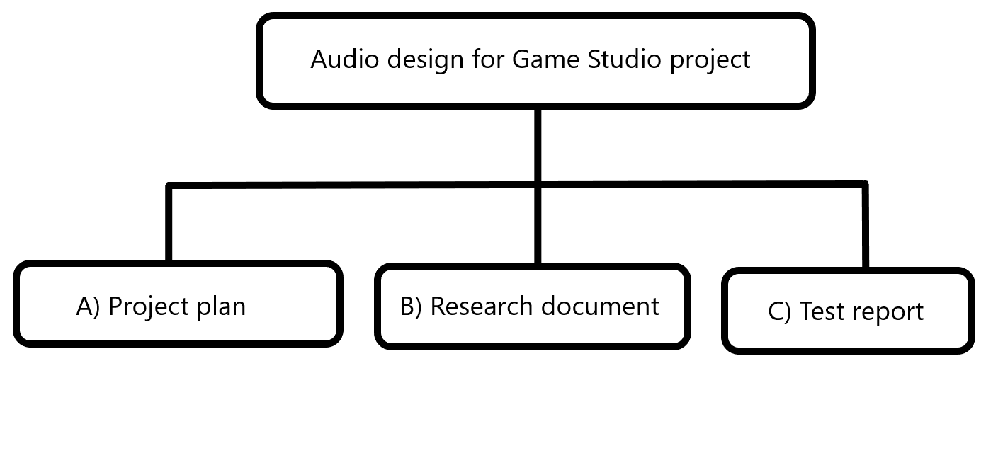

Project plan
This document, containing the details of the setup of the project.

Research document
The document containing the research questions and the research itself. This will be used directly to implement and improve the product.

Test report
A document containing the tests performed and the results of the tests, which will be used to improve the product.

Project organization

Stakeholders and team members
Name | Abbreviation | Role and functions | Availability
Sander Theeuwen  s.theeuwen@student.fontys.nl  +31 6 10433821 |  | Developer. | Monday: 8.00  23.00  Tuesday: 8.00  23.00  Wednesday: 8.00  17.00  Thursday: 8.00  23.00  Friday: 8.00  23.00  Saturday: 8.00  23.00  Sunday: 8.00  23.00
Bernd-Jan Witkamp  bj.witkamp@fontys.nl |  | Semester coach.

Communication
MS Teams is the main form of communication online. Preferably, all meetings will be held offline. Meetings will be held to give progress updates, making sure the project is managed well and productivity remains constant. This is also an opportunity for validation of the current state of the project.

Activities and time plan

Time plan and milestones
Phasing | Effort | Start date | Finish date
Setup | 10% | 12-09-2023 | 07-10-2023
Research | 30% | 08-10-2023 | 15-10-2023
Development (sound gathering, making music) | 30% | 16-10-2023 | 29-10-2023
Testing and implementing feedback | 30% | 30-10-2032 | 17-11-2023

Testing strategy and configuration management

Testing strategy
Because of the shortage of time, the product will be tested with users only. Observation and surveys are the most used testing methods in the project, as the goal of the project is about user experience.

Risks and mitigation
Risk | Prevention activities | Mitigation activities
Teacher falling ill | - | Meetings will be held online as much as possible.  If online meetings are not possible, a second teacher will be contacted for further guidance.
Student falling ill | - | The project will be continued online as much as possible.

